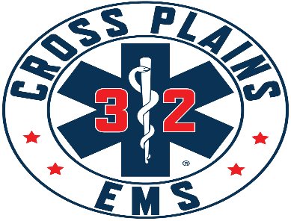

Cross Plains Area Emergency Medical Services District Board
Meeting Agenda
May 13, 2026 @ 7:00 p.m.
Town of Cross Plains Town Hall, 3734 County Hwy P

ToJoinByZoom:
https://us02web.zoom.us/j/81707632718?pwd=0bluGycQOPRq0cZ1LgaMG8SM0VcN68.1
To Join by Phone: 16469313860
Meeting ID: 817 0763 2718
Passcode: 295157

- Call to Order at 7:01 pm

- Roll Call: Greg Hyer, Holly Ellickson, Jay Lengfeld, Dave Laufenberg, Dwayne Haag here in place of Mike Statz due to illness.

- Pledge of Allegiance

- Public Comment – This is an opportunity for anyone to address the Cross Plains EMS Board on any issue. Please observe the time limit of 3 minutes. While the Cross Plains EMS Board encourages input from residents, it may not discuss or act on any issue that is not duly noticed on the agenda. THOSE WISHING TO SPEAK DURING THE MEETING ARE ENCOURAGED TO REGISTER PRIOR THE START OF THE MEETING. YOU MAY ALSO REGISTER YOUR COMMENT BY SENDING AN EMAIL TO Chief@crossplainsems.com by 4:00PM ON THE DAY OF THE MEETING.

- Discussion/Action on Cross Plains EMS District Agreement. Village of Cross Plains passed final draft with three conditions. Page 4 – Include Exhibit A which is map of territory. Page 1, first paragraph needs to state date when this will take effect. Signature page needs to remove the and be signed by Clerk/Treasurer or just Clerk. Delete need for notary. Agreement to start on July 1, 2026.
Town of Cross Plains will vote on this agreement on 5/14/26 at 7pm.
Town of Berry will vote on this on Monday, May 18th.
Town of Springfield will vote on this on Tuesday, May 19th.
Village of Cross Plains will vote on this June 8th meeting.
If all pass, we will gather all signatures and make PDF file and send to everyone and place on Cross Plains EMS website.

- Adjournment at 7:22 pm

