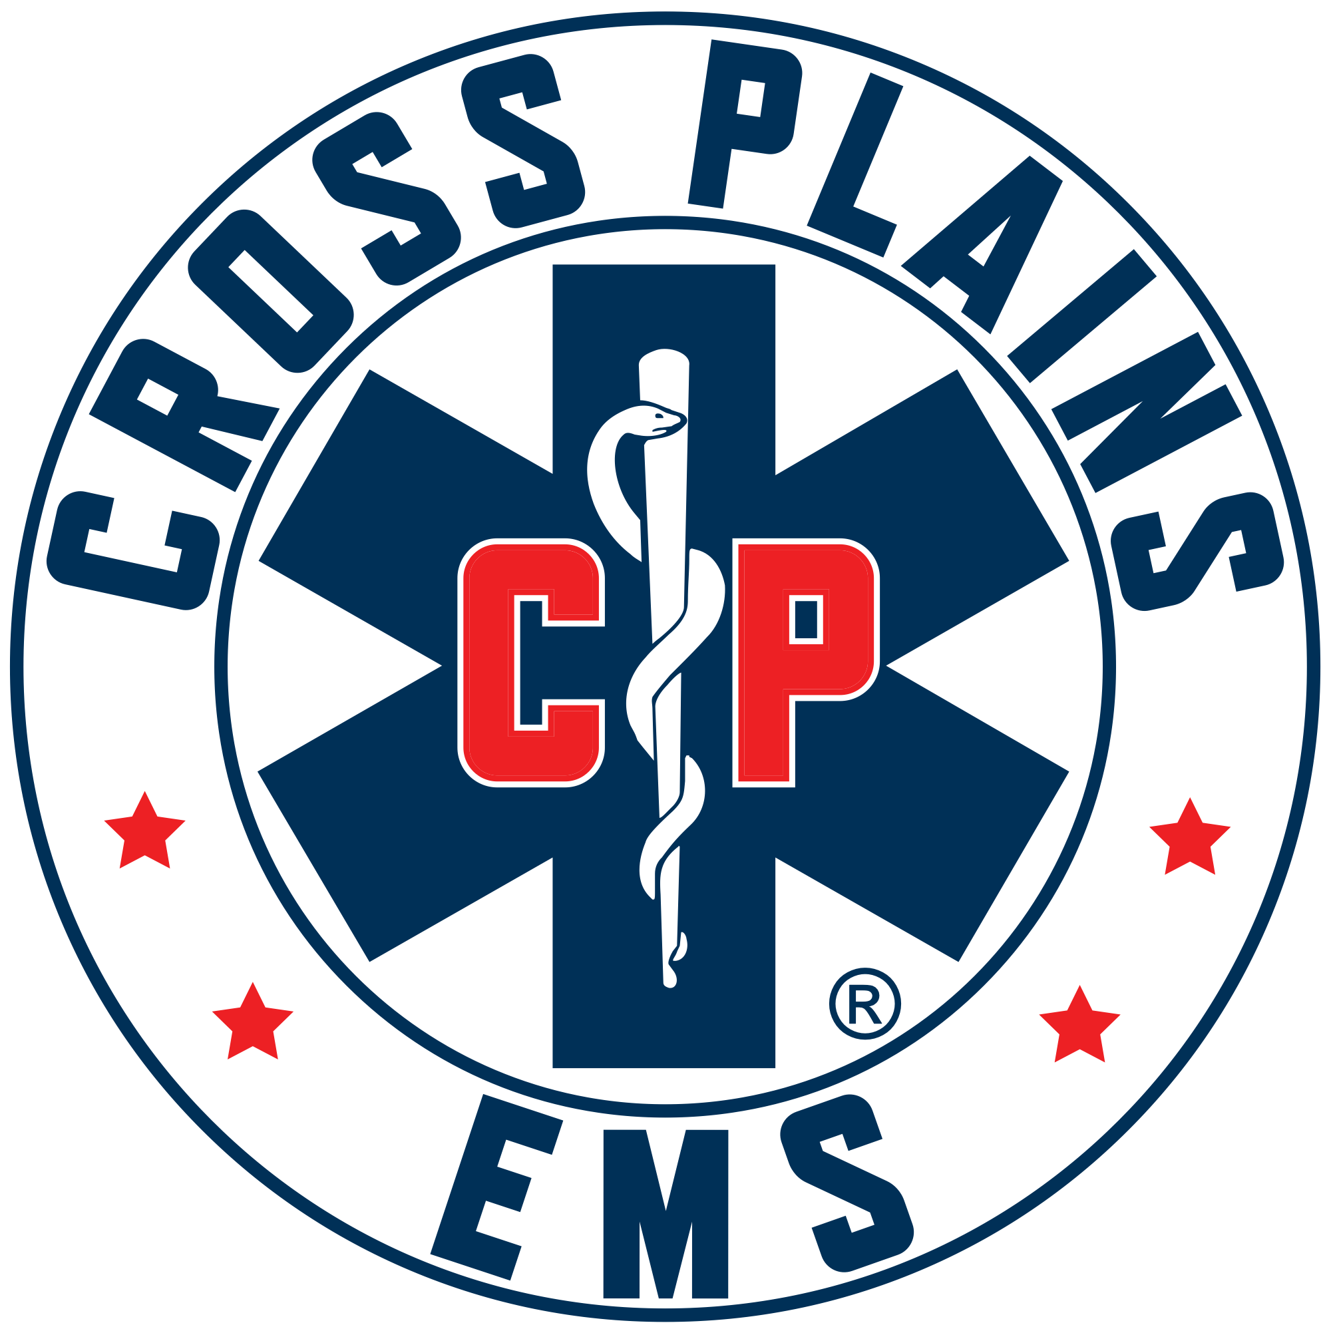 Cross Plains Area EMS District Meeting Agenda
Wednesday, April 15th at 7:00 p.m.
Town of Cross Plains Town Hall, 3734 County Hwy P

To Join By Zoom: https://us02web.zoom.us/j/81707632718?pwd=0bluGycQOPRq0cZ1LgaMG8SM0VcN68.1
To Join By Phone: 16469313860
Meeting ID: 817 0763 2718
Passcode: 295157

- Call to Order at 7:00 p.m.
- Roll Call: Greg Hyer, Jay Lengfeld, Dave Laufenberg, Mike Statz, Holly Ellickson, Brian Pitt all present.
- Pledge of Allegiance.
- Public Comment: C. J. Robinson states he is concerned as the July deadline is just around the corner. If this is dragged out anymore we will not meet the deadline. Keep moving forward, work together. The public, the EMS and the Corporation are waiting.
- Approval of February and March meeting minutes. Dave made a motion to approve February and March meeting minutes as written. Jay seconded this. Motion passed.
- Discussion/Action on Cross Plains EMS District Agreement. Rick Manthe, Lawyer for the Town of Cross Plains, via Zoom. Agreement discussion, group went page by page for corrections/revisions. New Draft with changes will be sent out. This will be sent out prior to May 1st. This way all municipality boards will be able to review and have their lawyers look at agreement.
- Discussion/Action on First Quarter Financials
- Budget. No questions.
- All Account Balances at end of First Quarter – No questions.
- Checks written from January 1, 2026 – March 31, 2026. Mike made a motion to approve all checks listed above. Dave seconded this motion. Motion passed.
- March Visa Bill, previously approved by Greg Hyer. No concerns.
- FAP Funds Spent – Chief reports some funds left, will give report next meeting.
- Discussion/Action on Community EMS. Chief gets update that she and Brian should be done with class at the end of April. They have been shadowing many providers, and they are all excited to get this started. We will accept referrals from Hospitals, Clinics, Police department, etc. Once we have protocols in place we will give presentation to Board.
- Discussion/Action on IFT and payment to staff. State of Wisconsin just approved our operational plan for 911 and IFT. Discussion on how to properly keep stats, income and expenses for this project. Will add line items in 2027 budget.
- Discussion/Action on AI use policy. Dave makes a motion to approve policy as written. Mike seconded this. Motion approved.
- Discussion/Action on Vacation/Sick time. Chief would like to change EMS policy to match Village of Cross Plains Policy. Greg makes a motion to accept new policy. Mike seconded. Motion passed.
- Update for Cross Plains EMS Association. Kelly states they are now a corporation. They have new by laws in place. Yearly fundraising letter will be out in the next few weeks.
- Adjournment. Motion made by Greg. Seconded by Dave. Motion passed. Next meeting is May 13, 2026, 7:00 p.m, Town of Cross Plains.

